
Distribution Sheet 2021
FAMILY SWAP

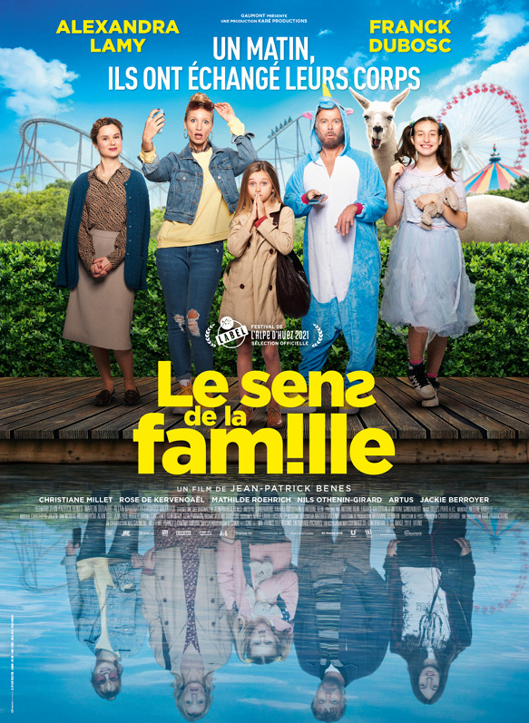
One morning, the Morel family wakes up with a major problem on their hands. Their bodies and souls have undergone a total reshuffling. The 6-year old girl now finds herself in the body of her father, who is now in the body of his teenage son, who is now in the body of his older sister, who is now in the body of her mother…who is now in the body of six-year old Chacha. You don´t get it? Neither do they. And this is just the beginning…

Release Date: | 9. 9. 2021 | Original Title: Le Sens de la famille
Length: | 92 min. | Genre: comedy
Sound/Format: | 5.1/2D | Director: Jean-Patrick Benes
Version:  Rating: | Czech subtitles  PG 13 | Cast: Alexandra Lamy  Franck Dubosc
Country of Origin: France  World Sales Rights: Gaumont  Year of Production: 2021 |  | Cast: Alexandra Lamy  Franck Dubosc

Programming: Marketing/PR:
Lucie Mazůrková GSM: 605 288 996 program@bohemiamp.cz Eva Hartmanová GSM: 733199020 hartmanova@bohemiamp.cz

Bohemia Motion Pictures, a.s., Všehrdova 560/2, 118 00 Praha 1 – Malá Strana

