
MY SWEET MONSTER
Distribution Sheet 2022
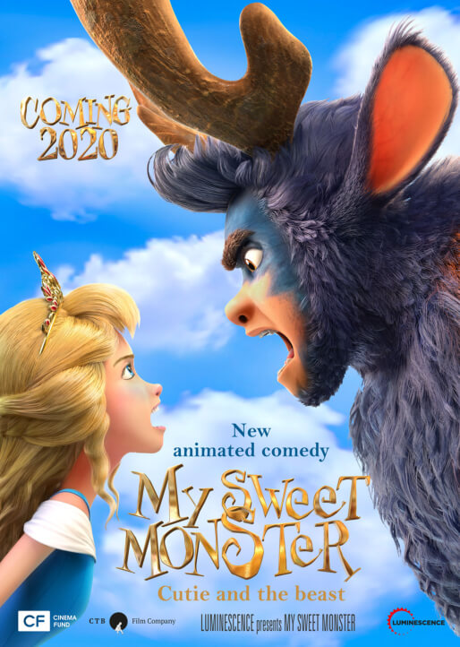
Release Date: | 27.1.2022 | Original Title: MY SWEET MONSTER
Length: | 100 min. | Genre: animation
Sound/Format: | 2D | Director: Viktor Glukhushin  Maksim Volkov
Version:  Rating: | Czech dubbing  G | Cast:
Country of Origin: Russia  World Sales: Luminescence  Year of Production: 2021  trailer |  | Cast:

Tired of living by her father’s dos and don’ts, rebellious princess Barbara runs away from the royal palace. She falls into the hands of the monstrous forest bandit Bogey and turns his life upside down. Barbara attempts to dictate her own rules in Bogey’s native forest. Being a creature of the wild, Bogey hates her for that but, as we all know, the line between hatred and love can be very thin...

Programming: Marketing/PR:
Lucie Mazůrková GSM: 605 288 996 program@bohemiamp.cz Eva Hartmanová GSM: 733199020 hartmanova@bohemiamp.cz

Bohemia Motion Pictures, a.s., Všehrdova 560/2, 118 00 Praha 1 – Malá Strana

