
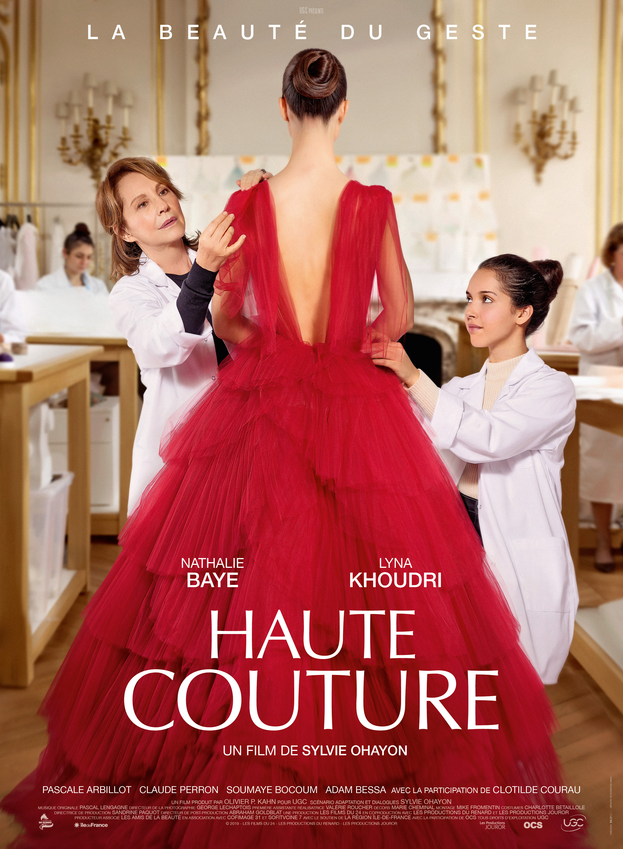
HAUTE COUTURE
Distribution Sheet 2022

The House of Dior works closely on the costumes and sets of the film.

Esther is at the end of her career as Head Seamstress at Dior Avenue
Montaigne workshop. One day, she gets her handbag stolen in the metro by a
20 years old girl, Jade. Instead of calling the police she decides to take care of
Jade. She sees in her the opportunity to pass on her skills, the craft of
dressmaking, her only wealth. In the frenetic world of Haute Couture, Esther
will give Jade la beauté du geste, a way to reach beyond herself.

Release Date: | 17. 3. 2022 | Original Title: Haute Couture
Length: | 101 min. | Genre: drama
Sound/Format: | 2D | Director: Sylvie Ohayon
Version:  Rating: | Czech dubbing  G | Cast: Nathalie Baye  Lyna Khoudri  Pascale Arbillot  Sylvie Testud
Country of Origin: France
World Sales: Orange
Year of Production: 2020
trailer

Programming: Marketing/PR:
Lucie Mazůrková GSM: 605 288 996 program@bohemiamp.cz Eva Hartmanová GSM: 733199020 hartmanova@bohemiamp.cz

Bohemia Motion Pictures, a.s., Všehrdova 560/2, 118 00 Praha 1 – Malá Strana

