
AINBO
Distribution Sheet 2021
Spirit of the Amazon

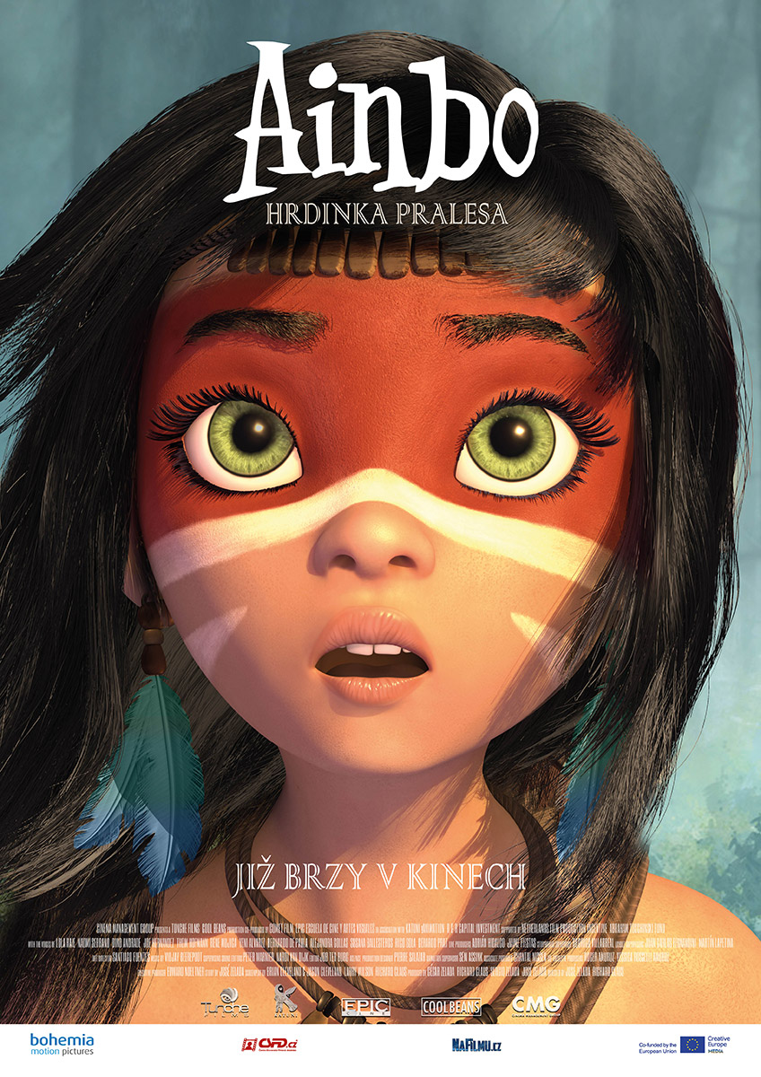
Ainbo is the story of a young girl who was born and grew up in the deepest jungle of the Amazon in the village of Candamo. One day she discovers that her homeland is being threatened and realizes that there are other humans in the world besides her people. Using the help of her spirit guides, the skinny armadillo “Dillo” and the heavy-set tapir “Vaca”, she embarks on a journey to seek help from the most powerful Mother Spirit of the Amazon, Turtle “Motelo Mama”. As she fi ghts to save her paradise against the greed and exploitation of illegal gold-mining, she struggles to reverse the destruction and the impending evil of the “Yacaruna”, the darkest demon that lives in the Amazon. Guided by her mother’s spirit, Ainbo is determined to save her land and her people before it’s too late.

Release Date: | 26. 8. 2021 | Original Title: AINBO: Spirit of the Amazon
Length: | 85 min. | Genre: animation
Sound/Format: | 2D | Director: José Zelada
Version:  Rating: | Czech dubbing  G | Cast:
Country of Origin: Peru/Neatherlands  World Sales: CMG  Year of Production: 2020  trailer |  | Cast:
Programming: Marketing/PR:
Lucie Mazůrková GSM: 605 288 996 program@bohemiamp.cz Eva Hartmanová GSM: 733199020 hartmanova@bohemiamp.cz

Bohemia Motion Pictures, a.s., Všehrdova 560/2, 118 00 Praha 1 – Malá Strana

